1.

2.

3.

4.

5.

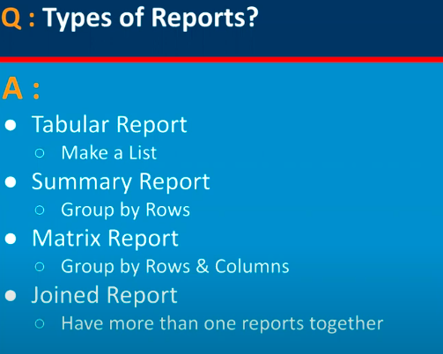

6.

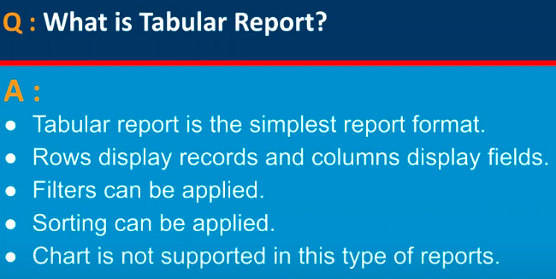

7.

8.

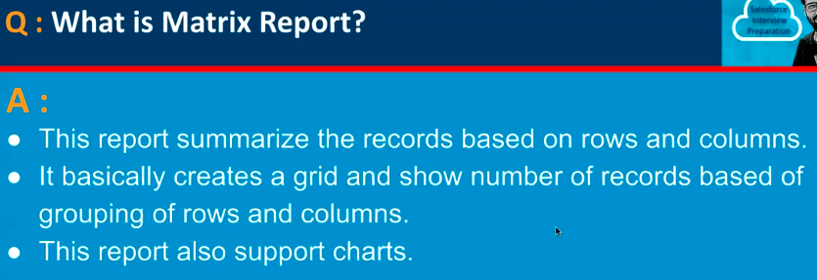

9.

10.

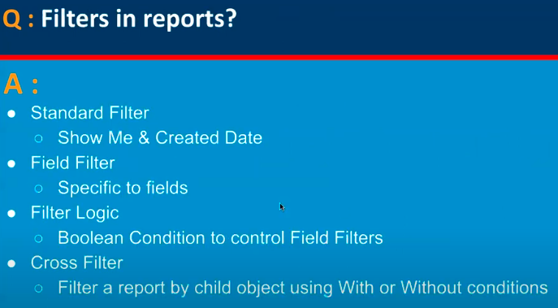

11.

12.

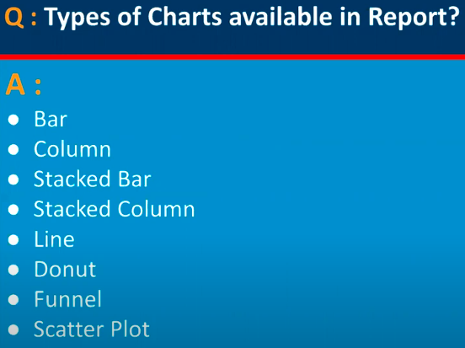

13.

14.

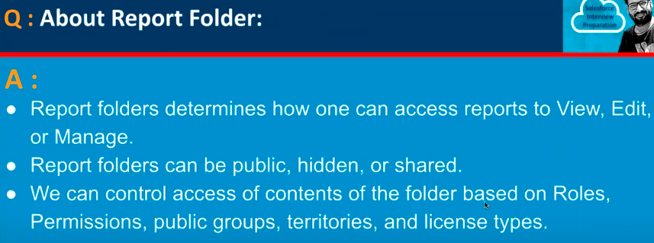

15.

16.

17.

18.

19.

20.

21.

22.

23.

24.

